Coding Style

* Python - pep 8
  + Reference: <https://www.python.org/dev/peps/pep-0008/>
* Javascript - Google JavaScript Style Guide
  + Reference: <https://google.github.io/styleguide/jsguide.html>

Dependencies & Installation

**“PostgreSQL” vs Django - postgresql 10.10 & django 2.2**

* **Download**: <https://www.enterprisedb.com/downloads/postgres-postgresql-downloads>
* **Research** - Dependency of postgresql & django  
  “Django supports PostgreSQL 9.4 and higher. [psycopg2](http://initd.org/psycopg/) 2.5.4 or higher is required, though the latest release is recommended.”  
  <https://docs.djangoproject.com/en/2.2/ref/databases/>  
  <https://www.postgresql.org/docs/10/index.html>

**“Python Package” vs Python - psycopg2 2.7.7 & python 3.7.1**

* **Download** & **Research** - What is psycopg?  
   “Psycopg is a PostgreSQL database adapter for the Python programming language.”  
  <https://pypi.org/project/psycopg2/2.7.7/>

**“Python” vs Django - python 3.7.1 & django 2.2**

* **Download**
  + Windows: <https://www.python.org/downloads/windows/>
  + Mac: <https://www.python.org/downloads/mac-osx/>
* **Research** - Dependency of python & django  
  <https://docs.djangoproject.com/en/2.2/faq/install/#targetText=Python%203%20is%20recommended.,of%20Python%203%20is%20recommended.>

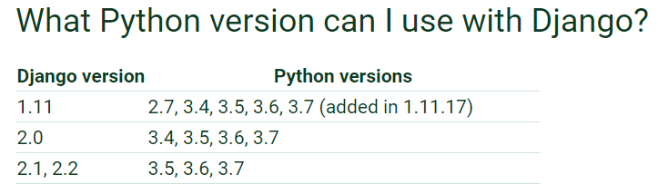

**“Django” - Django 2.2.5**

* **Download (Terminal & Command prompt)**: pip install Django==2.2.5  
  <https://www.djangoproject.com/download/>
* **Research**: Django 2.2.5 version  
  <https://docs.djangoproject.com/en/2.2/releases/2.2.5/>

**PostgreSQL GUI** - Pgadmin 4 v4.11

* **Download**:
  + Windows: <https://www.pgadmin.org/download/pgadmin-4-windows/>
  + Mac: <https://www.pgadmin.org/download/pgadmin-4-macos/>
* **Research**:  
  "pgAdmin may be used on Linux, Unix, Mac OS X and Windows to manage PostgreSQL 9.2 and above."  
  <https://www.pgadmin.org/>
* **Example from pgadmin 3:**

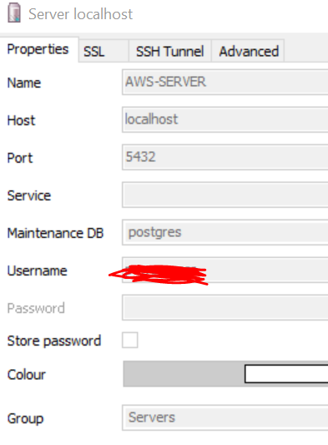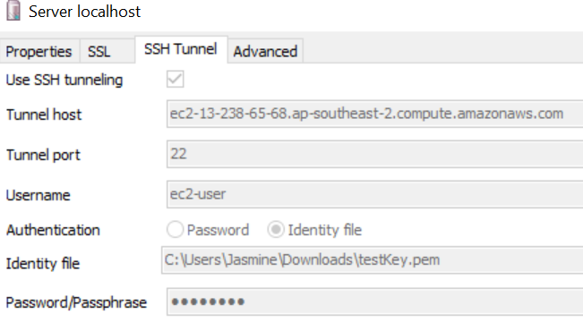

Ubuntu to run pgadmin4: (<https://linuxhint.com/install-pgadmin4-ubuntu/>)

python lib/python2.7/site-packages/pgadmin4/pgAdmin4.py

Additional:

Bootstrap for html, css, html

From Idea v1.

|  |  |  |
| --- | --- | --- |
| 12 | Cookie Forging Attack Prevention | // TODO |

|  |
| --- |
| **UC12 Flow of Events for the Cookie Forging Attack Prevention Use Case** |
| **12.1 Preconditions:** |
| The actor had access to the website with a stable internet connection and they are already authenticated. |
| **12.2 Main Flow:** |
| When actor access to this website, which had been accessed, Actors click login and are prompted to enter their scripts instead of providing remembered password. Once this is done, the attacker will reduce the chance to cooke foring |
| **12.3 Subflows:** |
| None |
| **12.4 Alternative Flows:** |
| If the actor’s password is changed, The system will ask actor to check your email account |

* UC & Diagram
  + Add Use case 12
  + Add uc12 into diagram
* Functional Requirement ?
* Non-functional Requirement ?